**DPL Ingestion steps:**

1. Check date in /apps/inv_qa/aum/code/ingestion/oozie/dpl/shell/dpl_done.txt file to make sure it shows correct start date of time period you want to ingest data.

For example: if the date is :2020-05-01, all records have proc_dt/last_dt >= 2020-05-01 will be ingested.

1. Login WINSCP as service account.
2. Stage trigger file ( ‘DPL_Load_20200501.txt’, empty inside) to landing folder:

/data-01/inv_landing_qa/aum/dpl

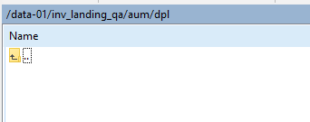

1. Start NIFI processor and then check in WINSCP the trigger file should be picked right away.

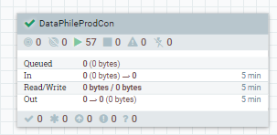

1. Wait for nifi to complete, and trigger the workflow:

cd /data-01/apps/inv_qa/**aum**/code/**ingestion**/shell

sh runcoordwf.sh wf dpl_daily run

RRD location:

<https://mfc.sharepoint.com/sites/GWAMIDDLProjects/FAUM/_layouts/15/Doc.aspx?sourcedoc=%7BF5151901-C4D3-47FD-8623-4B57BB5B8371%7D&file=BRD-Dataphile%20to%20EDL%20v.5a.docx&action=default&mobileredirect=true&CT=1590759497235&OR=ItemsView>

(STM, Data dictionary are in appendix).

**Sqoop steps:**

1. All Sqoop scripts are saved in below location and SP:

<https://mfc.sharepoint.com/sites/GWAMIDDLProjects/FAUM/Shared%20Documents/Forms/AllItems.aspx?viewid=00000000%2D0000%2D0000%2D0000%2D000000000000&id=%2Fsites%2FGWAMIDDLProjects%2FFAUM%2FShared%20Documents%2FTesting%2FTest%20Scripts%20%28HQLs%29%2FRel%201%2E1%2FDataphile%2FIngestion%2FTest%20Scripts>

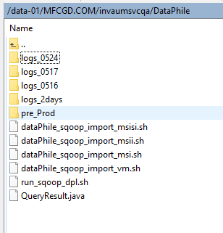

1. Create folder “logs” in same location.
2. Open run_sqoop_dpl.sh and change below parameters if needful. Process_date is partition will be added in test tables. Others represent the start date of the ingestion time period (refer to step1 of DPL Ingestion section).

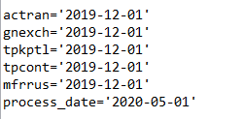

1. Change to /data-01/MFCGD.COM/invaumsvcqa/DataPhile folder in command line.

* Run run_sqoop_dpl.sh script
* Wait for sqoop process to complete.
* Test tables naming conventions are: inv_aum_raw_qa.dpl_actran

Connection strings for DPL prod:

msi_conn="jdbc:datadirect:openedge://10.201.170.28:1692;databaseName=exc2"

msisi_conn="jdbc:datadirect:openedge://10.201.170.28:3092;databaseName=exc2"

msii_conn="jdbc:datadirect:openedge://10.201.170.28:1792;databaseName=exc2"

vm_conn="jdbc:datadirect:openedge://10.201.170.28:1693;databaseName=exc2sm"